**Exploratory Data Analysis Report**

Customer segmentation project aims to know a company’s ideal customers on a deeper level. By understanding who they are, what they like, and how they behave, businesses can better tailor their products to fit the unique needs of different customer groups.

**Data set from** [**https://www.kaggle.com/code/annastasy/consumer-behavior-cluster-analysis-kmeans/notebook**](https://www.kaggle.com/code/annastasy/consumer-behavior-cluster-analysis-kmeans/notebook)

**Data shape: 2240, 27**

**Data info:**

|  |  |  |
| --- | --- | --- |
|  | ID | Customer's unique identifier |
|  | Year_Birth | Customer's birth year |
|  | Education | Customer's education level |
|  | Marital_Status | Customer's marital status |
|  | Income | Customer's yearly household income |
|  | Kidhome | Number of children in customer's household |
|  | Teenhome | Number of teenagers in customer's household |
|  | Dt_Customer: | Date of customer's enrollment with the company |
|  | Recency | Number of days since customer's last purchase |
|  | **Complain** | 1 if the customer complained in the last 2 years, 0 otherwise |
|  | MntWines: | Amount spent on wine in last 2 years |
|  | MntFruits: | Amount spent on fruits in last 2 years |
|  | MntMeatProducts | : Amount spent on meat in last 2 years |
|  | MntFishProducts: | Amount spent on fish in last 2 years |
|  | MntSweetProducts: | Amount spent on sweets in last 2 years |
|  | MntGoldProds: | Amount spent on gold in last 2 years |
|  | NumDealsPurchases: | Number of purchases made with a discount |
|  | AcceptedCmp1: | 1 if customer accepted the offer in the 1st campaign, 0 otherwise |
|  | AcceptedCmp2: | 1 if customer accepted the offer in the 2nd campaign, 0 otherwise |
|  | AcceptedCmp3 | 1 if customer accepted the offer in the 3rd campaign, 0 otherwise |
|  | AcceptedCmp4: | 1 if customer accepted the offer in the 4th campaign, 0 otherwise |
|  | AcceptedCmp5: | 1 if customer accepted the offer in the 5th campaign, 0 otherwise |
|  | NumWebPurchases: | Number of purchases made through the company’s website |
|  | NumCatalogPurchases: | Number of purchases made using a catalogue |
|  | NumStorePurchases: | Number of purchases made directly in stores |
|  | NumWebVisitsMonth: | Number of visits to company’s website in the last month |

**Data Description**

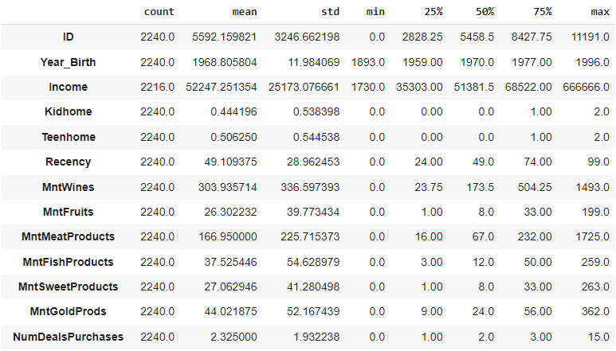

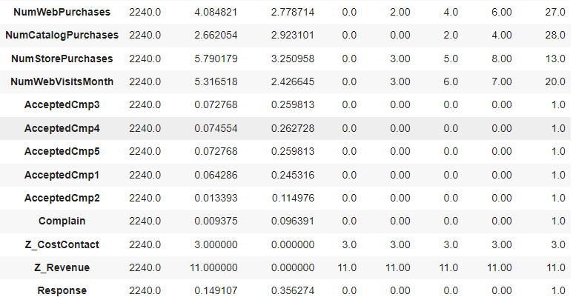

**Univariate Analysis**

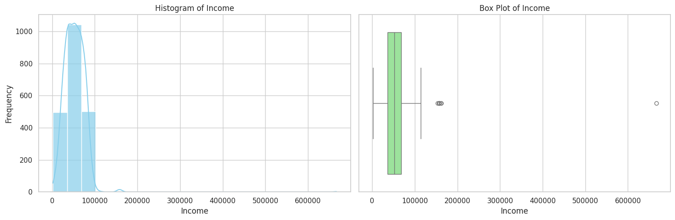

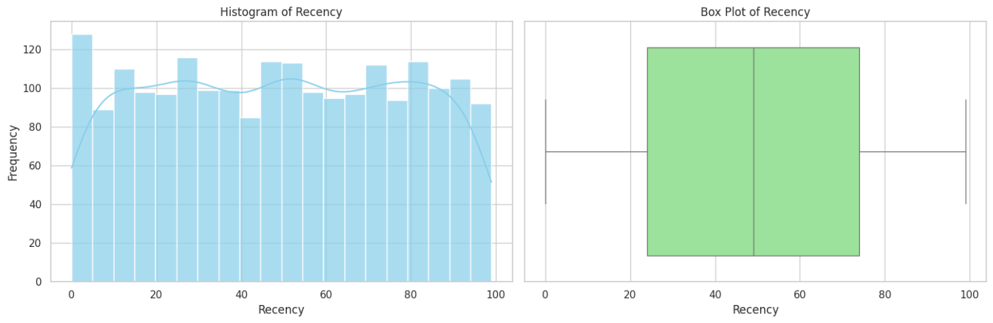

**Univariate Analysis for categorical data**

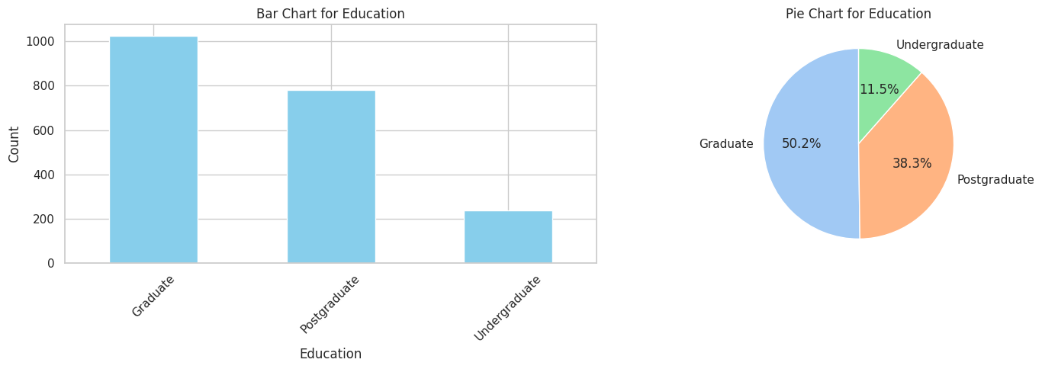

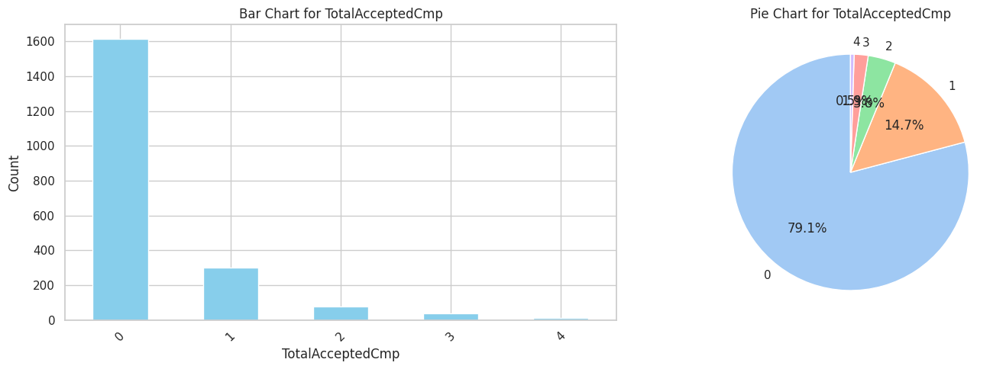

**Bivariate Analysis**

The following scatter diagram shows relation between income and spend of customers

